
Department of CSE

B.Tech. CSE Trimester -5

Roll Number - 2520030586
Name – Hamsika Peddina

Cloud Infrastructure and Services
25CS2206E

LAB RECORD
2026

Skill Experiment -1

AIM: To create an IAM User, Generate Access Key, AWS Billing Alert Configuration and Enable Multi-Factor Authentication for Root User account

Description:
To create an IAM user with programmatic access only, generate and download the Access Key ID and Secret Access Key, and configure an AWS billing alert to receive an email notification when the Free Tier usage approaches or exceeds the specified limit.

Steps:
Part A: Create an IAM User with Programmatic Access Only
- Log in to AWS Console with root account credentials.
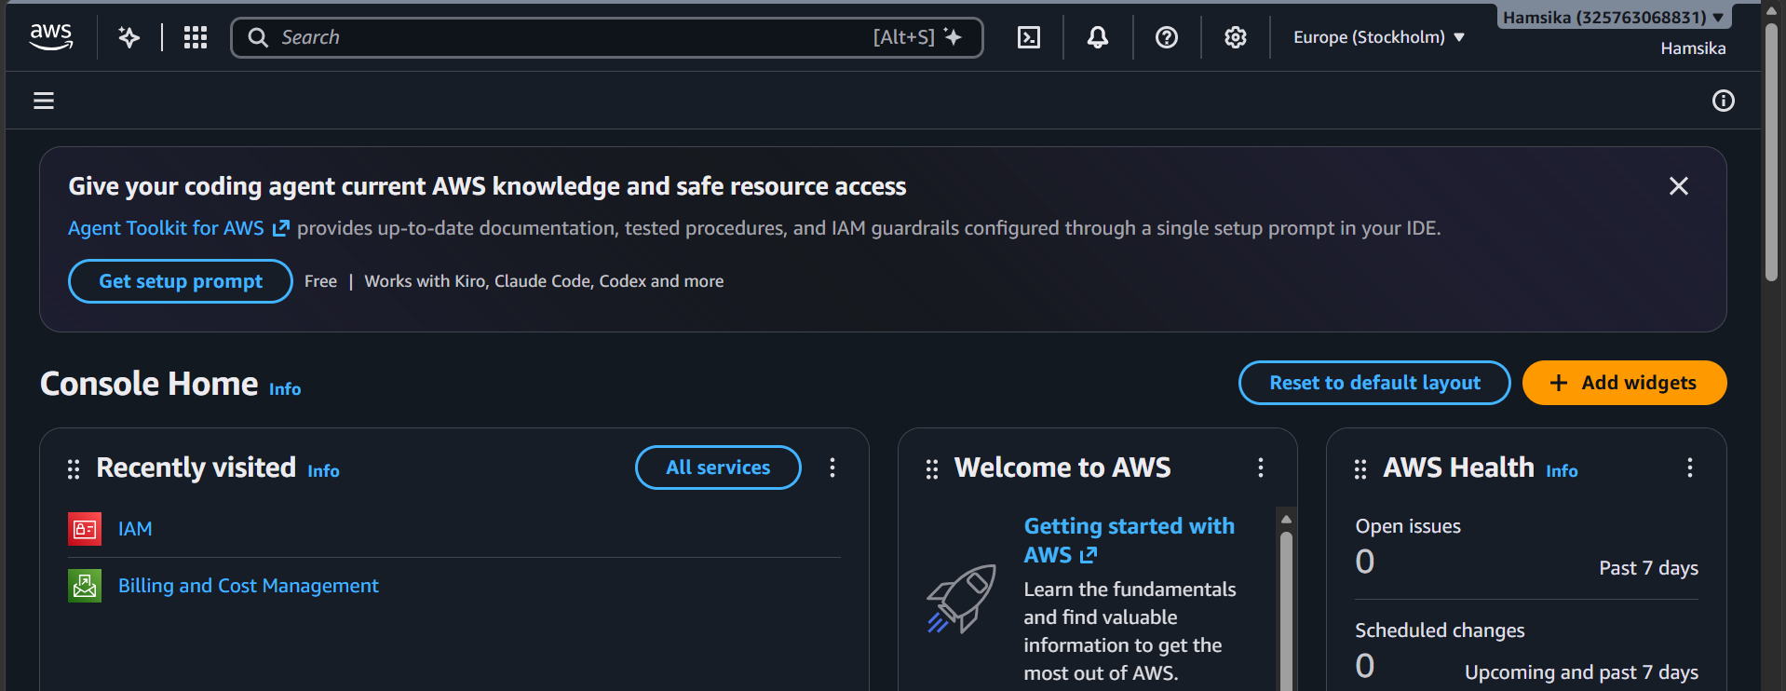
- Search for IAM and select IAM
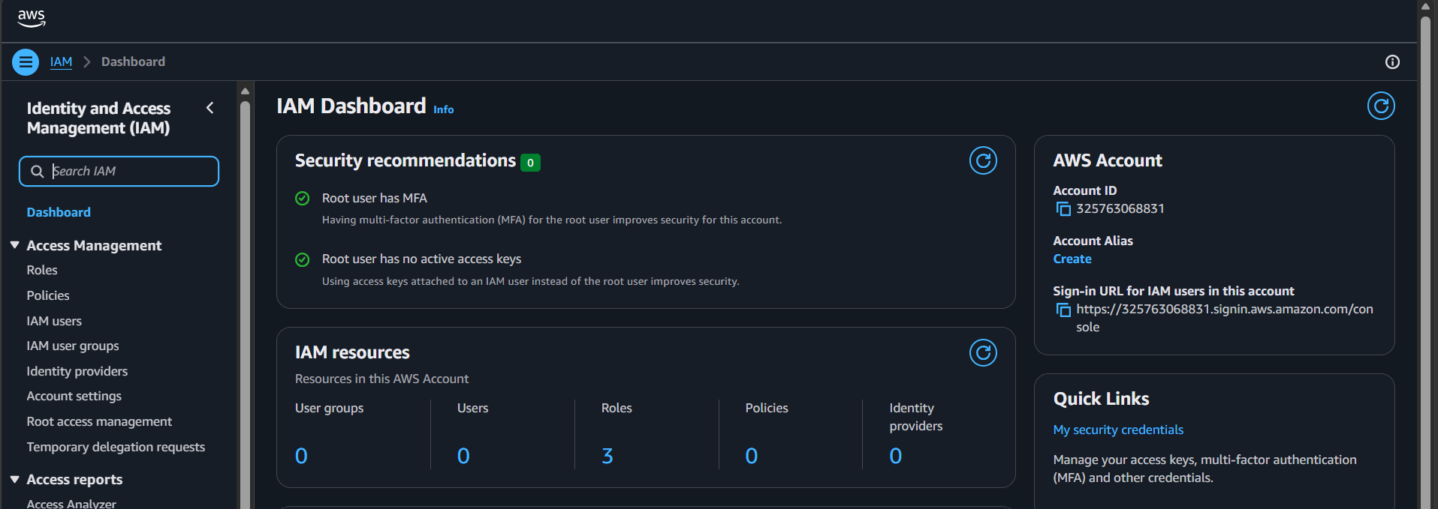
- Select Users from navigation bar.
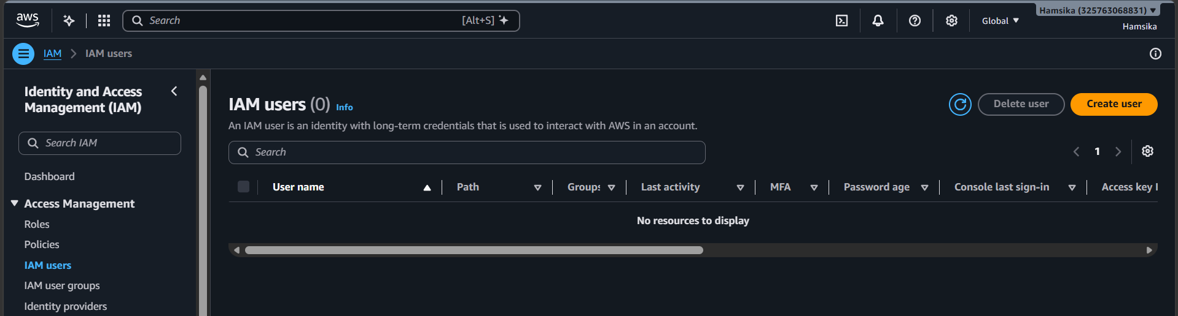
- Create user and enter a username
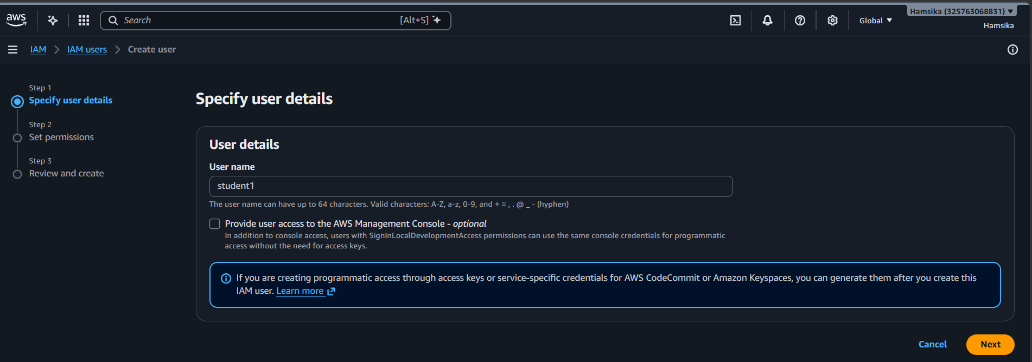
- Under set permissions, select Attach policies directly. Select the required permissions, click next and review the configurations.
Click create and you will have the user created.
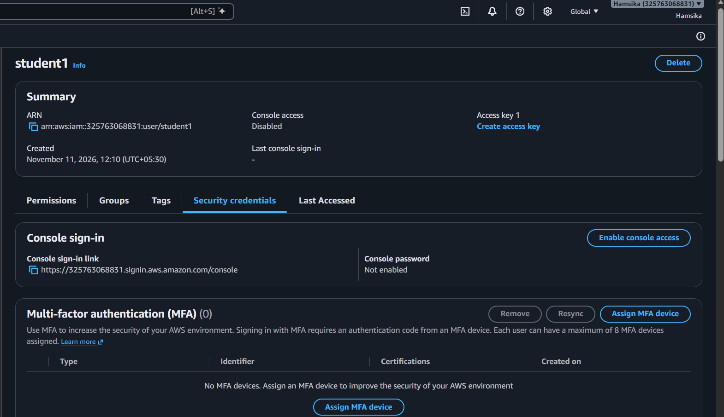

Part B: Generate and Download Access Keys
- Select the newly created user
Scroll down to Access Keys
Click on Create access key
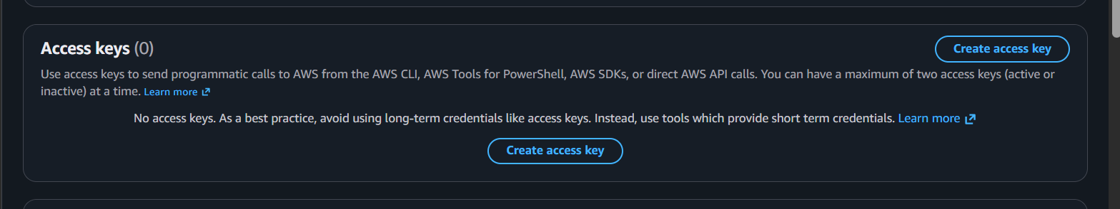
- Select the appropriate use case, such as Command Line Interface (CLI),
Acknowledge the recommendation and click Next
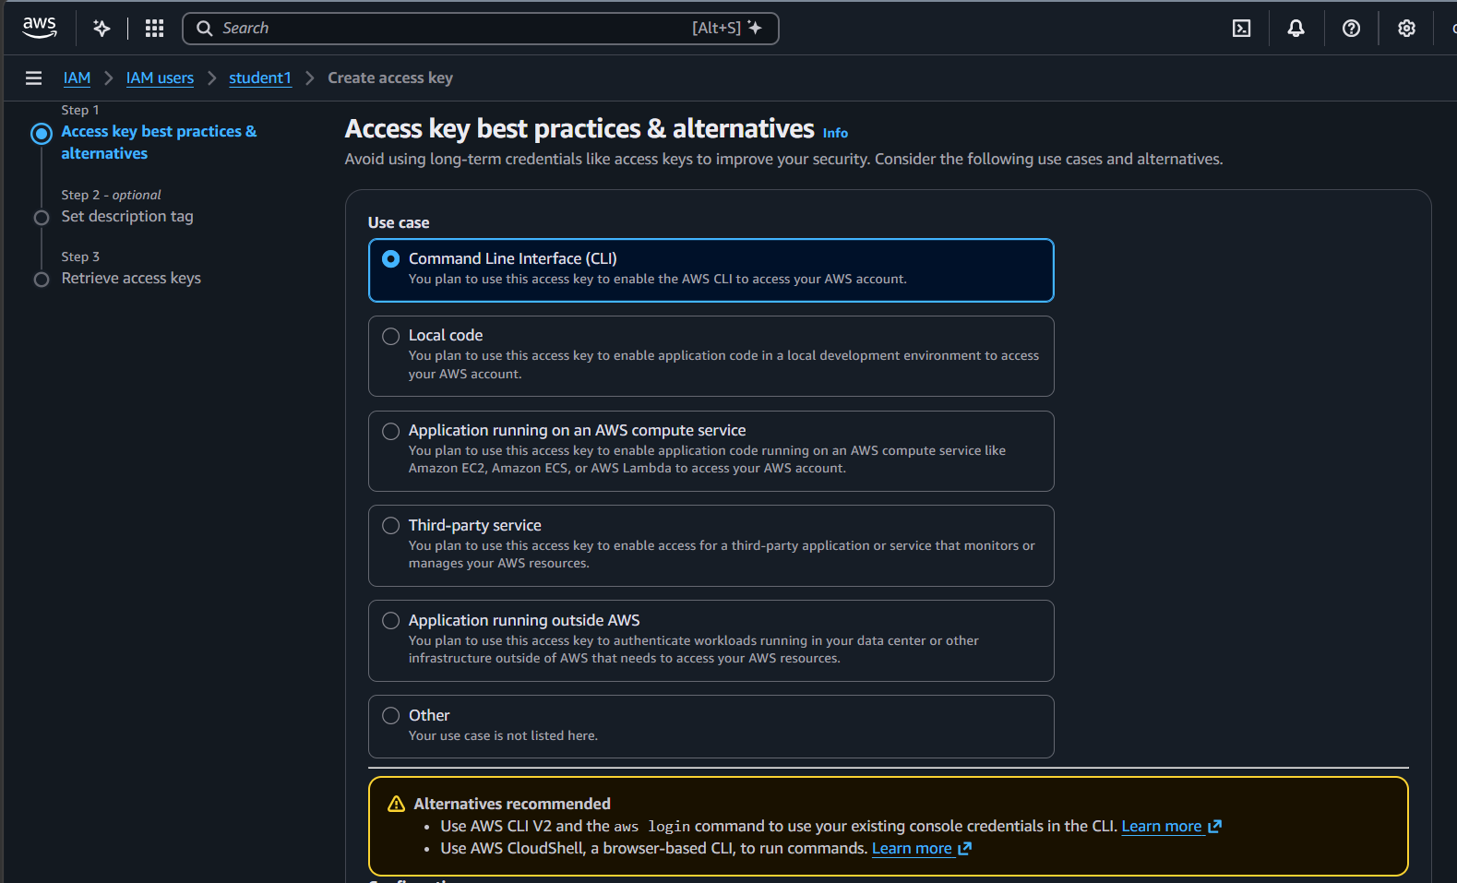
- Optionally enter a description tag and click on create access key.
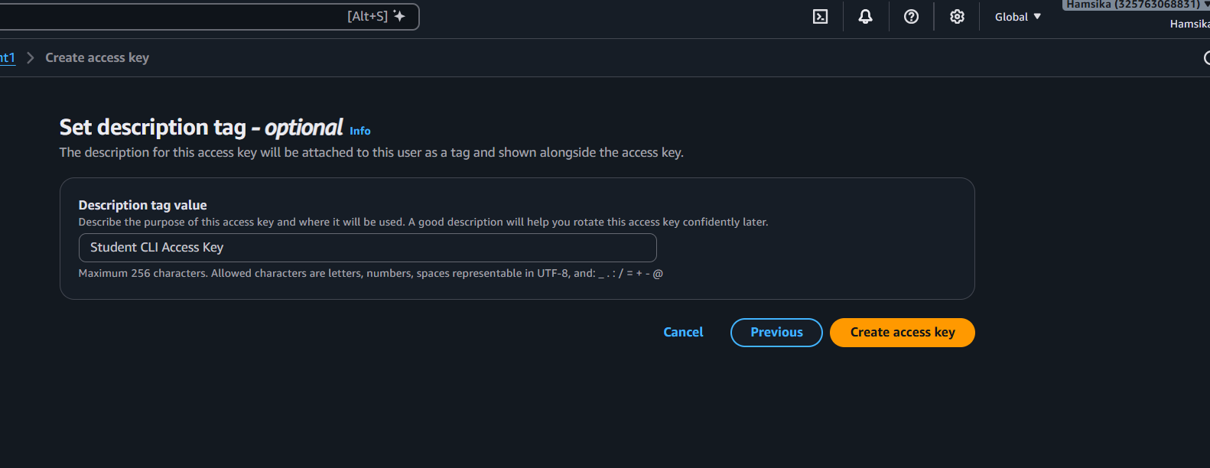
- The console displays the following credentials:
  - Access Key ID
  - Secret Access Key
Click Download .csv file
Click on Done
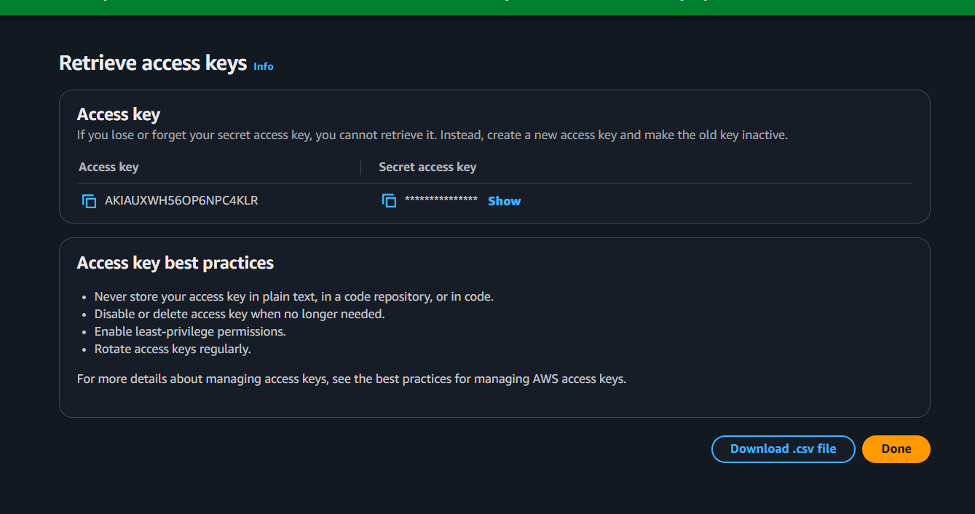
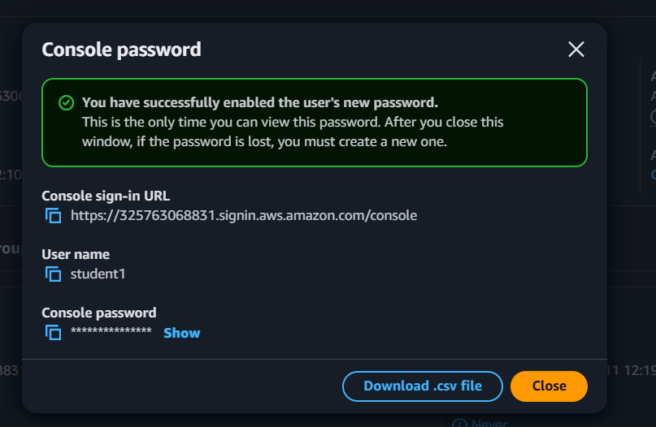
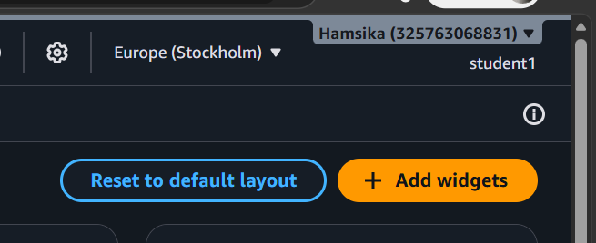

PART C: Configure AWS Billing Alerts Using the Custom Budget Option
1. Log in to the AWS Management Console using the root account.
Search for Billing and Cost Management and open it.
2.From the left navigation panel, select Budgets under Budgets and Planning.
3. Click Create budget.
4. Under Budget setup, select Use a template (simplified)
In Templates – new select Zero spend budget

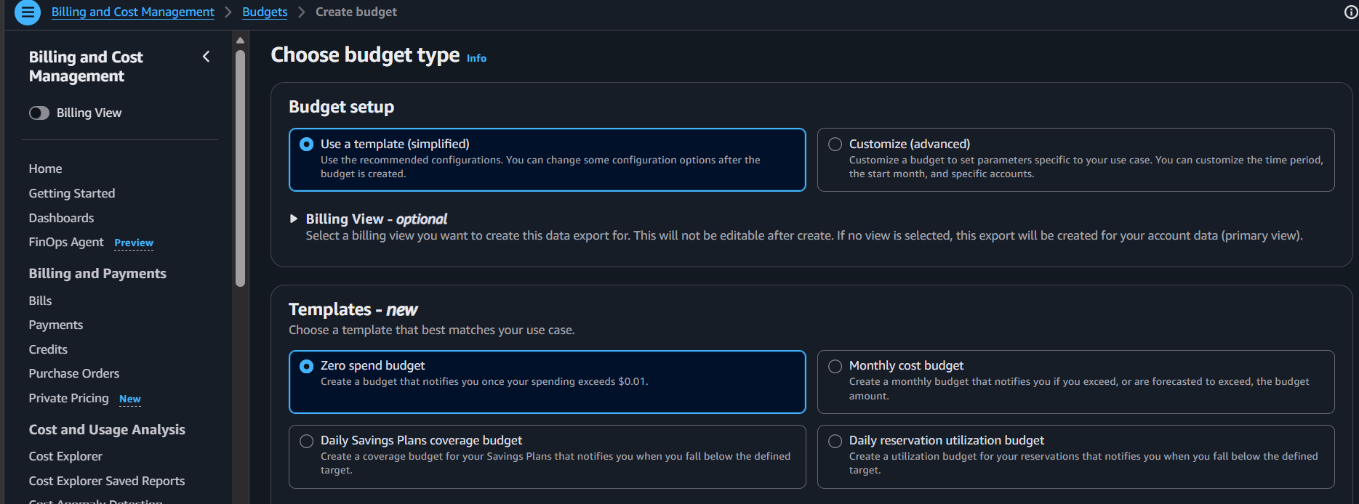

- Click Create budget
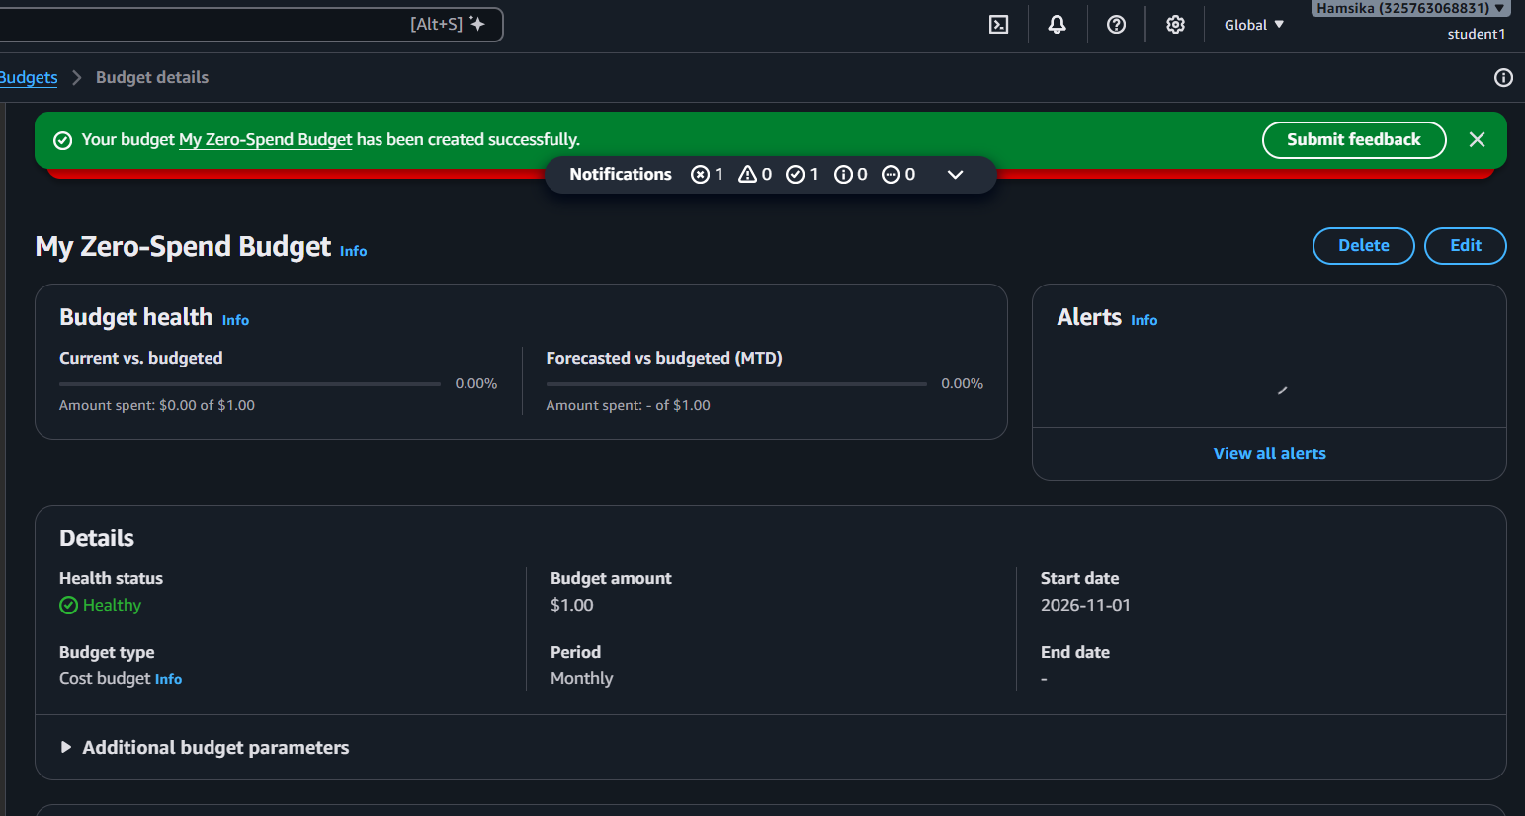
6. Verify that the newly created budget appears in the AWS Budgets dashboard
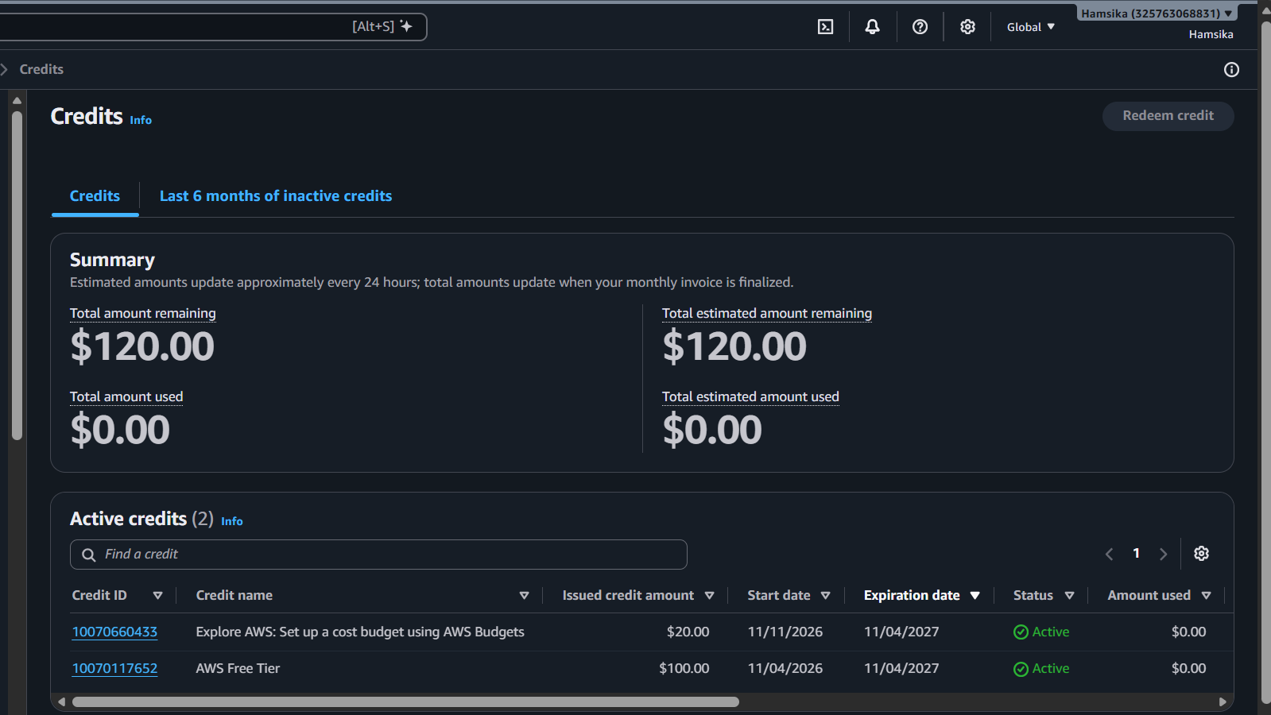

PART D: Enabling Multi-Factor Authentication for Root User Account
- Sign in to the AWS Management Console using the Root user credentials.
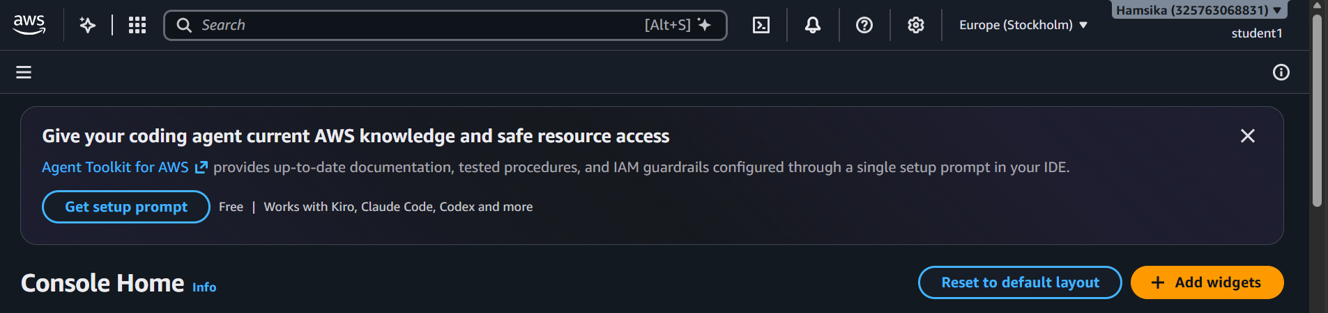
- Locate the Multi-Factor Authentication (MFA) section.
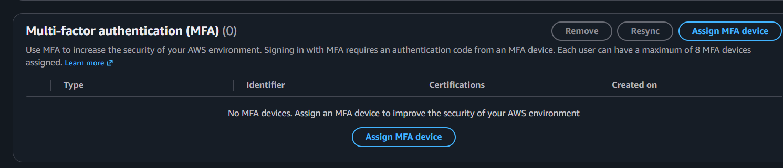
- Click Assign MFA device.
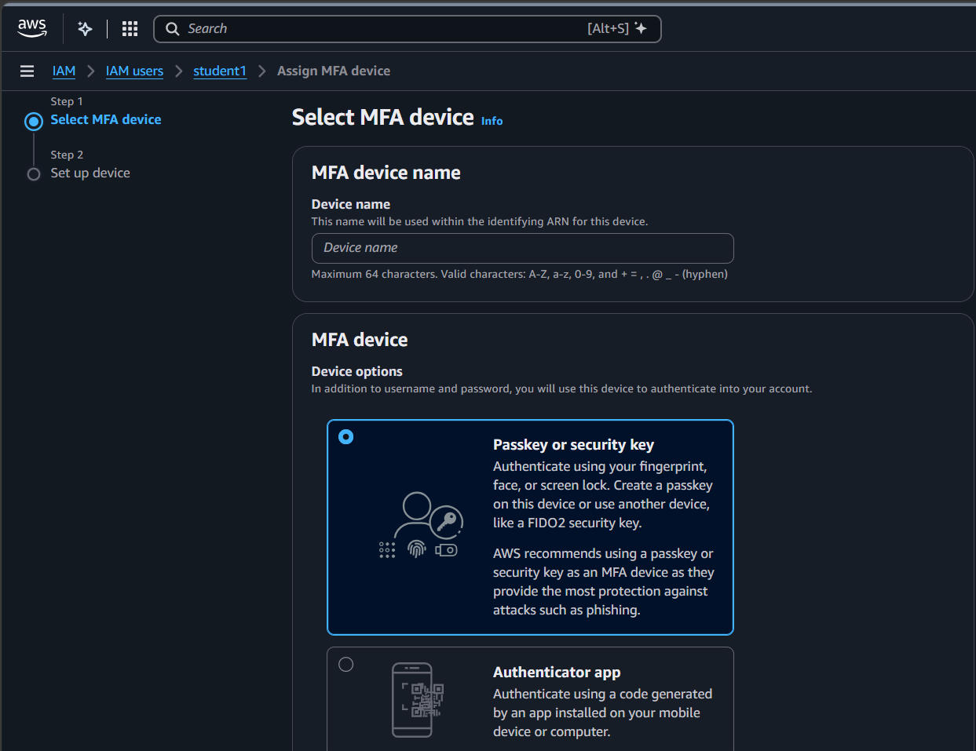
- Enter a device name
- Select the MFA device type:
  - Passkey or Security key
  - Authenticator app (Google Authenticator or Microsoft Authenticator).

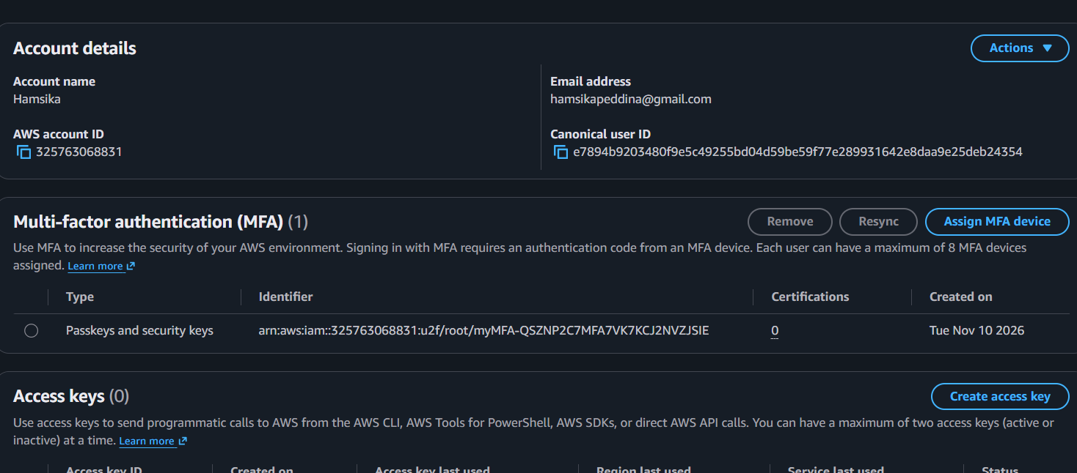

Output:
- Successfully create an IAM user without console access.
- Generate and download programmatic access credentials.
- Understand the importance of securely managing AWS access keys.
- Create a monthly AWS Budget with email alerts.
- Monitor AWS resource usage and control unexpected expenses.
- Multi-Factor Authentication is successfully enabled for the Root user

